# Let’s Discuss the Situation

Draft 0.02: Cory Casanave 5/19/2020

Contents

Let’s Discuss the Situation 1

TOC 1

Abstract 2

Situations; an intuitive understanding 2

Situation Model 3

Atomic situations (relationships and characteristics) 4

Composite Situations 4

Static Situations 4

Dynamic situations 5

Temporality 5

Occurrences 8

Statements 9

Actual situations and patterns 11

References 12

## Abstract

Information may be stored or shared in one of many natural languages or one of millions of “structured” forms that are typically defined in data or message “schema” – schema describe the structure of information. Natural languages are, by their nature, imprecise and dependent on deep shared context to understand meaning. Structured forms trade flexibility for a predictable structure that can be automated and precise **if the meaning is clear**. Yet that meaning typically falls back on natural language definitions that depend on programmers correctly interpreting the meaning encoded in the structure – an expensive and risk prone process.

Data schema are, by their nature, tuned to the applications and use cases for which they are designed. They frequently combine or “conflate” diverse concepts into an efficient data storage or message structures, that works for their design purpose which incorporates specific assumptions, but becomes confusing or misleading when that same information is needed for other purposes, or other stakeholders, in other formats. The assumptions inherent in a schema design are often unstated or even inconsistent.

Ontologies are increasingly being used to establish a consistent and formal basis for meaning such that the same “facts” can be interpreted correctly regardless of the structure, terminology, technology or schema that encodes them. For this vision to be realized the various schema need to be mapped to a common conceptual model expressed in an ontology.

What has proved challenging in this approach is establishing common concepts that are both sufficiently broad and sufficiently precise to federate these different data structures. Sometimes the same conflation of concepts that “polluted” data schema creep into supporting ontologies – either for the sake of efficiency, limits imposed by the ontology language, or the influence of legacy. For this reason, the search or appropriate “linking concepts” is central to a broad-based information federation, sharing or analytics requirement.

We will discuss two such concepts which have proved valuable as essential linking concepts, what we call “situations” and “statements”. These concepts provide a separation of concerns between the world as we conceive it and “statements” about that conceived world. Statements include all forms of communications and recorded information – anything that is “said about” the world. Situations are conditions of the world it’s self; sets of relationships and properties that, together, comprise a meaningful topic for statements. In more formal language, statements are epistemological (about what we know or communicate) where as situations are ontological (about the world).

This approach draws on a rich tradition of situation semantics initially developed by Barwise & Perry in the “situation underground” (Barwise, 1980) paper, and further advanced by Keith Devlin in *Situation Theory and Situation Semantics* (Devlin)*.*

We argue that this separation of concerns makes ontologies used as schema concept references more precise and more flexible by not conflating what is said with who is saying it. The result is an improved foundation for information sharing, analytics and machine learning.

## Situations; an intuitive understanding

Situations arise when there is more than one discreet thing conceived of as connected in a common context over a period of time.

In their 1980 paper “The Situation Underground” (Barwise, 1980), the first published work on situation semantics, Barwise and Perry wrote of situations:

“The world consists not just of objects, or of objects, properties and relations, but of objects having properties and standing in relations to one another. And there are parts of the world, clearly recognized (although not precisely individuated) in common sense and human language. These parts of the world are called situations. Events and episodes are situations in time, scenes are visually perceived situations, changes are sequences of situations, and facts are situations enriched (or polluted) by language.”

Consider these three essential distinguishing features of situations:

* That there is more than one discreet thing
* That there is a set of relationships (or properties) connecting these things
* That these relationships (or properties) hold for a time period
* That the situation provides a unifying context for the set of related things

We also relate situations to statements, initially just consider one person saying something to another. If I were to say “that cup” (pointing to a coffee cup), there is no information – it is not a complete sentence – “that cup” is not a situation; it is just one discreet thing, there are no relationships, there is no timeframe.

Consider “that cup is on my table”. Now we have two things – cup and table, we have a relationship between them “on” (or on-ness) and we now the time “is” (or now). “cup on table now” meets all of the requirements of a situation. Consider other example situations and non-situations

|  |  |
| --- | --- |
| Situation | Not a situation |
| A cup falling off of a table | A cup |
| The Novel Corona Pandemic | Covid-19 |
| The lifetime of George Washington | George Washington |
| The height of a person (or any other physical characteristic) at a particular time. | 6 feet |
| The change of a person’s temperature over a timeframe (or any other change) | 2 Degrees per hour |
| Sue’s obligation for a person to pay for a medical service | The general concept of a medical service |
| John’s healthcare appointment at 2PM | John |

### Situation Model (Top Level)

What has been expressed above may be formalized in a model as follows.

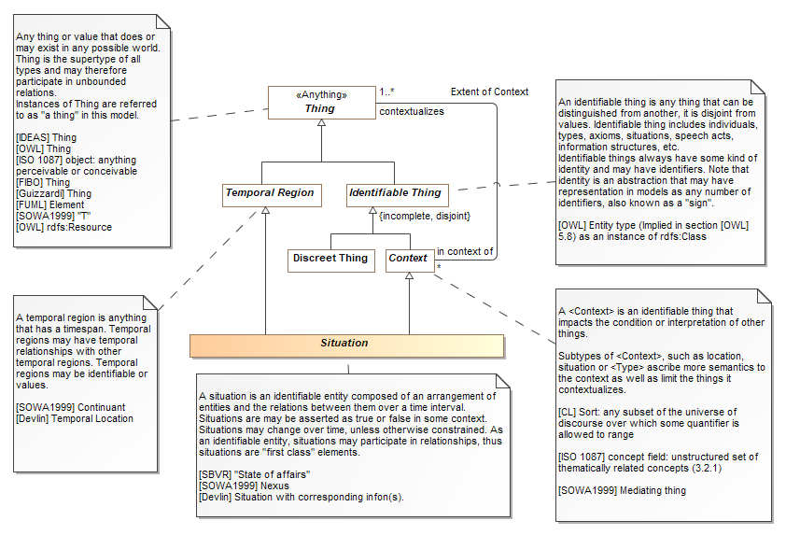

### Atomic situations (relationships and characteristics)

Considering the distinguishing features of situations what is the most minimal, most atomic situation? Fundamental relationships between things, frequently just two things over a timeframe, meet the criteria for a situation. “cup on table now” is such an atomic situation, which we call a relationship. E.g. a relationship is an atomic situation. Take away any element and there is no longer a situation, and no relationship. Atomic situations include relationships to “values” such as “John weighs 150lbs today” – these may also be called “properties”, “attributes” or “characteristics” – the value or quantity counts as one of the “discreet things” – so in this case there are two discreet things – john and 150lbs, as well as the timeframe “today”. The semantic of weight is captured as the meaning of the relationship.

Atomic situations are a context for related things.

### Composite Situations

At the other end of the scale, situations can be as “big” as needed from “the lifetime of the universe” to an office visit to the course of a disease and its treatment. Composite situations compose (have parts) – and are a context (container) for, a set of other situations (which may be composite or atomic).

### Static Situations

Some situation, or states, compose a set of things that are not changing over the lifetime of the situation. “cup on desk” is such a situation – it is “true” as long as the cup is there. Static situations can also be complex (if you could see my desk you would know!). A static situation could be the arrangement of seats in a movie theater. A person’s temperature (or other characteristic) at a given time.

Other terms include “State”, or “State of affairs”. We will use “State” as our preferred term.

### Dynamic situations

Dynamic situations represent things “happening”, some change over time – the cup falling off the desk, the patients temperature changing, the progression of COVID-19. Other terms include “events”, “Occurrences”, “activities” and more formally “perdurants”. We will use “Occurrence” as our preferred term.

By unifying static and dynamic concepts under situations we have a common concept that provides a foundation for temporality, causation, dependency and (as we will see below), statements.

#### Model of situation kinds

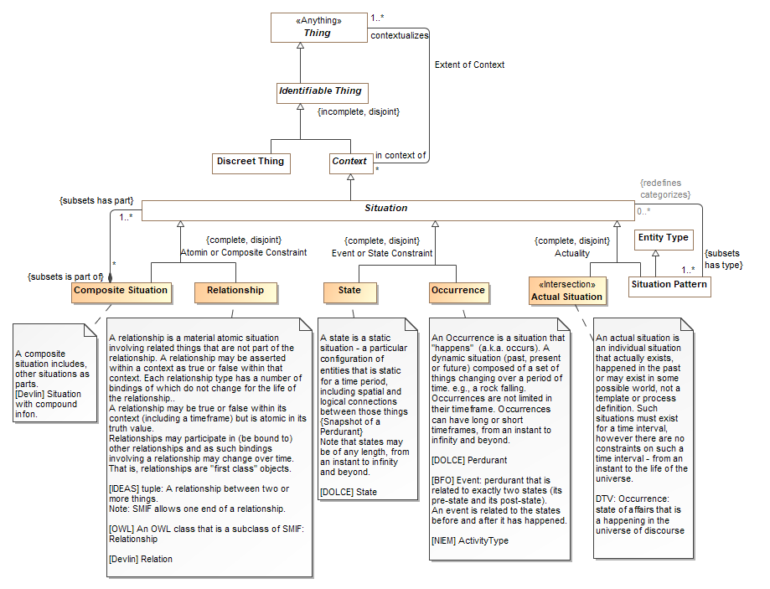

### Temporality

“Existing over a time period” has been asserted as a necessary component of situations. That time period could be instantaneous or extended, it may be known or unknown – but it exists. Even the existence of the earth has a time period – nothing lasts forever. More formally we say that a situation is a “temporal region” – it is bounded by a start and an end, now, in the past or in the future.

In the ontology world there is a challenge to understand time and change over time in a way that is both precise and understandable. By attaching time to situations, and to atomic situations, we can understand how the same things may have different characteristics and relationships at different times – yet remain the same thing. Things change because the situations they are involved in become “true” at different times. My weight in January 2001 and my weight in February 2020 are both valid representations of my weight, true at different times.

Another aspect of temporality is the temporal relationships between situations – before, after, during, etc. Anything that exists in time can be related to the timeframe of other situations.

Temporal regions can also be used to identify specific periods of time – time intervals. Time intervals represent “just time”, e.g. the year 2020. As such time intervals are considered values that may have a “data type” representation.

As both situations and time intervals are temporal regions, the “Allen relations” (e.g. before, after, etc.) may be stated between situations, between situations and time intervals or between time intervals.

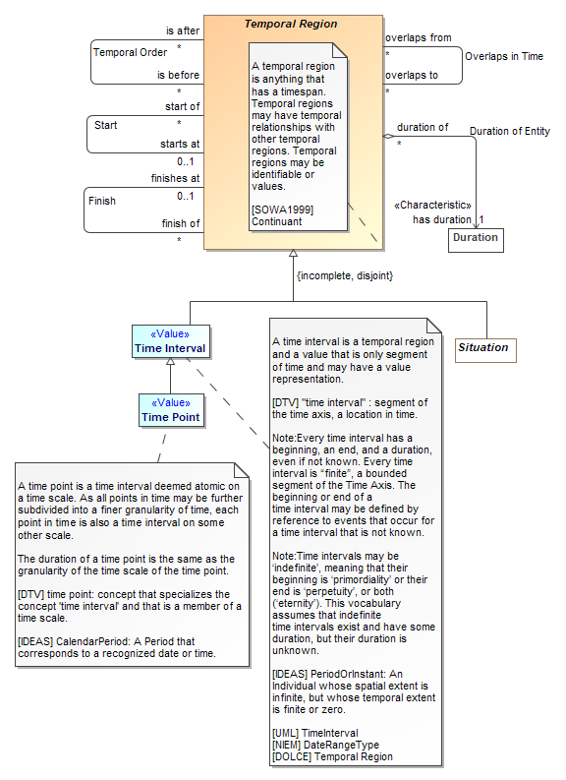

Occurrences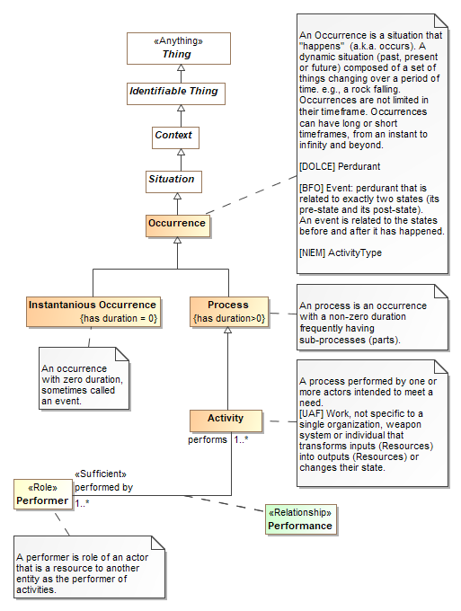

## Statements

In the introduction we discussed the separation of concerns between situations and statements. *Statements* are information ***about*** situations. Statements include “speech acts” (any communication), records, documents, information, data, messages, etc. Any time information is communicated or “written down” (physically or virtually), it is a statement ***about*** one or more situations as ***stated or recorded by some author*** (real or virtual). Statements are our link to the world of information, information about situations.

Prepare for a bit of a mind-loop; *statements* are also “things in the world”, they happen at a particular time, they involve multiple things (at least a situation and the author). So, statements are situations themselves, but a particular kind of situation that is “about” another. However, the situation that is the statement may have a different time, context, source, trust or other factors that differ from similar factors in the situation it is about. For example, At 3pm Nurse Jane told Dr. Sue that John’s temperature was 112 degrees at 1pm based on an observation by Frank, using an electronic thermometer. That temperature was recoded by Sam at 3:10pm in the EHR. Based on this evidence, Dr. Sue concluded that John needed an intervention and ordered an ice bath at 3:15 pm which was subsequently performed from 3:30 to 4:30 on the same day.

Count the situations! By understanding that each situation has its own timeframe, participants and characteristics we can accurately record and decompose exactly what happened and connect related “chains of events”. We have a basis for recording dependencies, for provenance, for trust (e.g. what if the thermometer was later found to be faulty). When these different situations are “mixed together” in a data record, important basis for decision making can be lost or misconstrued.

The essential take-away is that the statement and the situation it is about it is about are different but related things.

In formalizing statement we separate the concept of *aboutness*, where aboutness captures any kind of situation that is about another. Statements are but one kind of aboutness.

Statements may be *utterances,* communications between an author and a listener or *records*, stored or remembered authored information.

#### Diagram of aboutness and statements

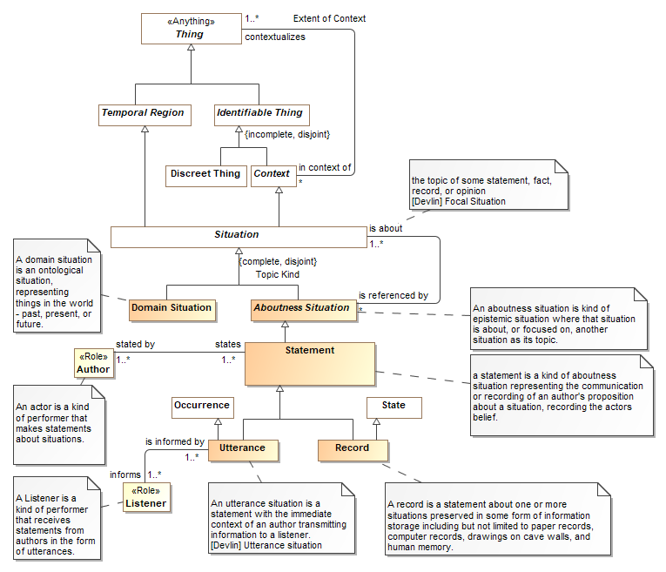

### Actual situations and patterns

The situation examples thus far have been what we call “actual situations” – a single individual “happening” over a specific timeframe. It is also important to be able to understand patterns of situations – be they the same kind of situation over and over (a shot administered daily for one year) or a pattern of different kinds of related situations, essentially a process.

Situation patterns differ from actual situations in that situation patterns have one or more “variables” in their composition – something that can change when the pattern in realized in an actual situation. In that a situation pattern describes a set of actual situations, it can be considered a situation “type” where A <Type> is a categorization of a thing based on specific criteria {reference to type theory}. The criteria in this case is that the actual situation “fits the pattern” of the situation type by the assignment of actual things to the variables.

Still working…

# References

Barwise, J. a. (1980). The Situation Underground. *Stanford Working*(Vol. 1), 1–55.

Devlin, K. (n.d.). *Situation Theory and Situation Semantics.* Retrieved from Stanford.edu: https://web.stanford.edu/~kdevlin/Papers/HHL_SituationTheory.pdf

|  |  |
| --- | --- |
| [UML] | OMG Unified Modeling Language (UML) v2.5  <http://www.omg.org/spec/UML/2.5/> |
| [OWL-2] | W3C/TR REC-owl2-syntax:2009 OWL 2 Web Ontology Language: Structural Speciation and Functional-Style Syntax. W3C Recommendation, 27 October 2009. http://www.w3.org/TR/2009/REC-owl2-syntax-20091027/ |
| [NIEM] | <http://reference.niem.gov/> |
| [WGS-84] | <http://earth-info.nga.mil/GandG/wgs84/> |
|  |  |
| [NIST-SI] | <http://physics.nist.gov/cuu/pdf/sp811.pdf> |
| [NIST-800] | <http://csrc.nist.gov/publications/PubsSPs.html> |
| [BFO] | <http://ifomis.uni-saarland.de/bfo/> |
| [MathWorld] | From *MathWorld*--A Wolfram Web Resource. [http://mathworld.wolfram.com](http://mathworld.wolfram.com/) |
| [CL] | ISO Common Logic, ISO/IEC 24707:2007(E) |
| [ISO1087] | Terminology work — Vocabulary, 2000, ISO 1087-1 |
| [SOWA1999] | John F. Sowa, *Knowledge Representation: Logical, Philosophical, and Computational Foundations*, 1999, ISBN 0-534-94965-7 |
| [ERGO 2018] | http://coherentknowledge.com/wp-content/uploads/2017/05/ergo-manual.pdf |